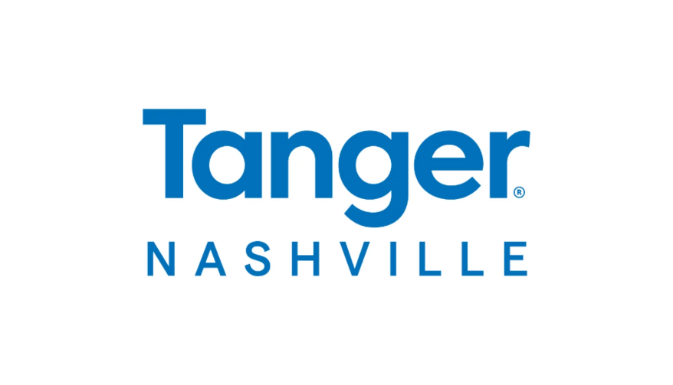

**For More Information:**

Brianna Poplaskie

BRAVE Public Relations

404.233.3993

[bpoplaskie@emailbrave.com](mailto:bpoplaskie@emailbrave.com)

**Tanger Outlets Nashville Expands Dining Offerings with New Eateries and Updates**

*Regional shopping destination adds Eggspectation and Surcheros to center line-up,*

*plus Red Bicycle expands offerings*

**NASHVILLE, Tenn. (Aug. 27, 2024) – Tanger Outlets Nashville** continues to set itself apart as an innovative retailing experience by expanding its restaurant line-up. National brands **Eggspectation** and **Surcheros** are joining the shopping destination, with local favorite **Red Bicycle** also welcoming changes, including delicious menu updates.

“At Tanger Nashville, we pride ourselves on offering a one-of-a-kind community experience,“ said Tanger Nashville Marketing Director Mackenzie Reagan. “We’re always seeking new ways to make the guest experience that much better. We believe the addition of these top eateries is the perfect way to continue our growth and offer more opportunities for shoppers to extend their visit.”

The Tanger Nashville **Surcheros’** location will be the company’s first in Tennessee. Founded in Georgia, the fast-casual Tex-Mex chain will bring its Southern hospitality to the Music City along with its perfectly grilled meats, fresh veggies and toppings, and signature sauces. The new restaurant is set to open this fall in a 2,700-square-foot space next to Shake Shack.

**Eggspectation**, now openfrom 7 a.m. to 9 p.m.next to Prince’s Hot Chicken, will be the first full-service dining option at Tanger Nashville, including a full bar and patio seating. The location will also mark the brand’s first in Tennessee. With more than 30 locations spanning six countries, Eggspectation is internationally beloved for its innovative and memorable take on familiar comfort foods. The new 4,000-square-foot restaurant is set to serve up all-day brunch, including elevated plates of French toast, Benedicts and omelets, as well as lunch and dinner options such as hand-crafted sandwiches, fresh seafood, steaks and more.

Nashville-favorite **Red Bicycle**, which opened along with the center last year, will test out a few tasty changes this fall. The coffee shop and roaster will extend their hours and expand seating options to account for its exceptional popularity at the center. The menu is also due to see updates, including new fall drink recipes.

# # #

**About Tanger Nashville**

Tanger Nashville is Middle Tennessee’s upscale, open-air outlet shopping destination, featuring a coveted collection of locally and nationally acclaimed retail brands, eateries and experiential offerings – including a vibrant collection of outdoor murals. In addition to an industry-leading community space for programming and activations, the center highlights Tanger’s extensive experience and investments in sustainable operations, advanced security measures, and charitable partnerships supporting the health and well-being of the surrounding community. The 290,000-square-foot center features more than 50 retail stores offering real style and everyday savings. Shopper-favorite brands at Tanger Nashville include Ulta Beauty, J. Crew Factory, Coach, Nike, Pottery Barn Outlet and Adidas. Guests can fuel their shopping trip with delicious options such as Shake Shack, Prince’s Hot Chicken and Crumbl Cookie. For a full store listing and map, as well as directions, events and scoop on the latest sales, visit [tanger.com/nashville](https://www.tanger.com/nashville), download the Tanger App or connect on [Facebook](https://facebook.com/tangeroutletsnashville) and [Instagram](https://www.instagram.com/tangeroutletsnashville). Guests can also access the ultimate shopping experience by joining [TangerClub](https://www.tanger.com/tangerclub), Tanger’s exclusive loyalty program, for curated offers and rewards.